Getting Ready for Summer Vacation
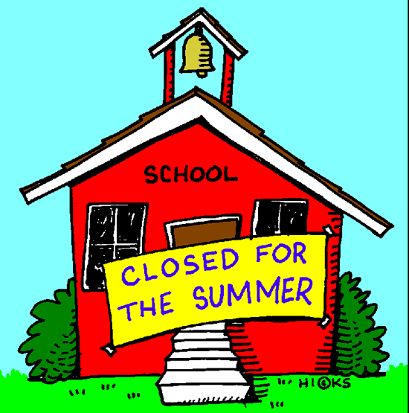
In days we will start summer holidays.
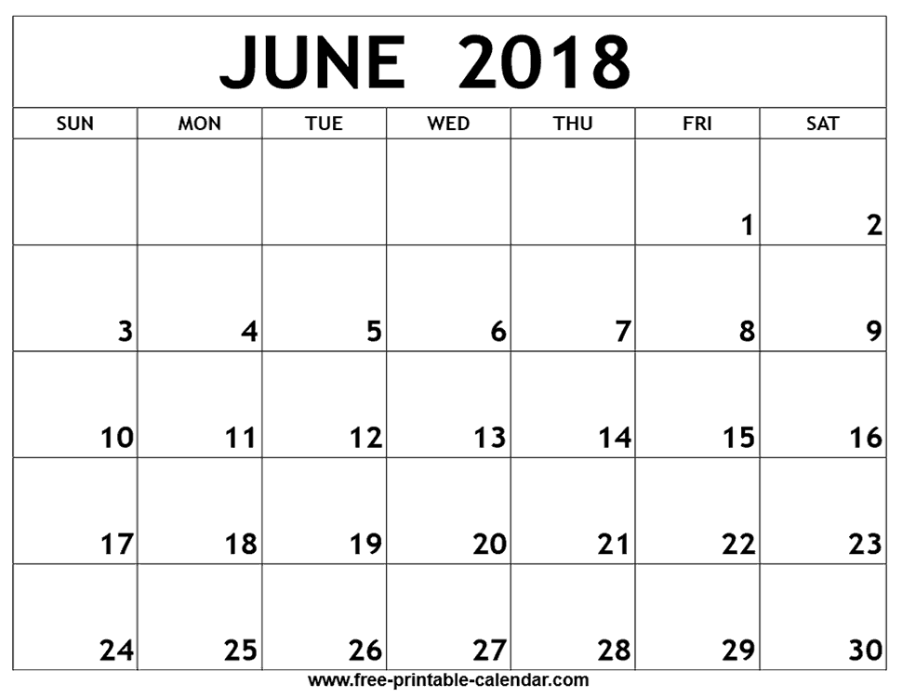

Thinking about summer holidays makes me feel .
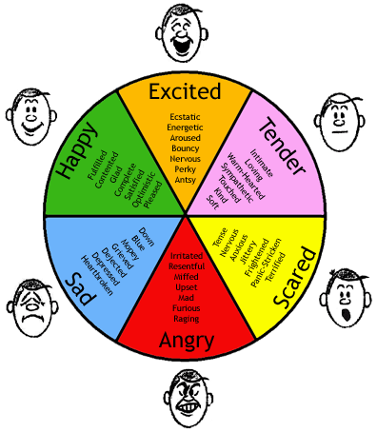

We won’t go to school during summer holidays.
I will be at home with my family. My teachers and my classmates will be home with their families too!
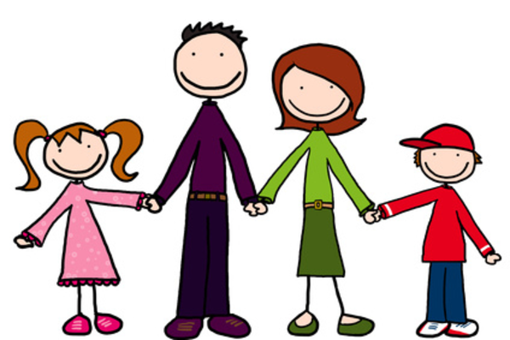
This summer I might go swimming, go to the park, go to the mall, watch movies, play games, read books, or visit the library. I would also really like to .
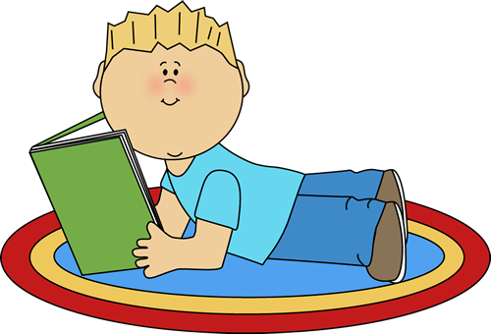
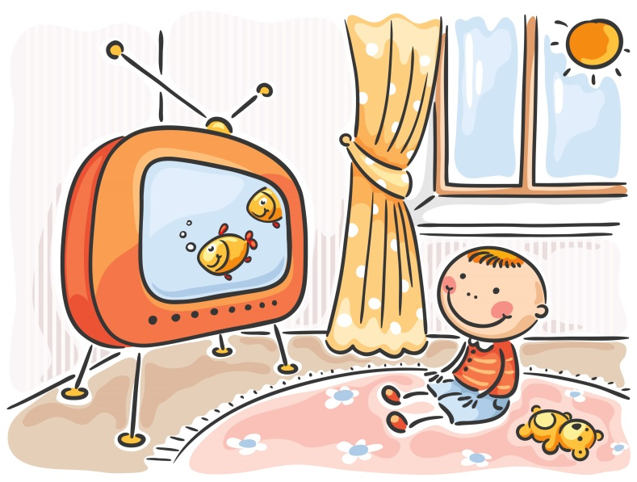
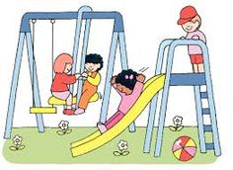
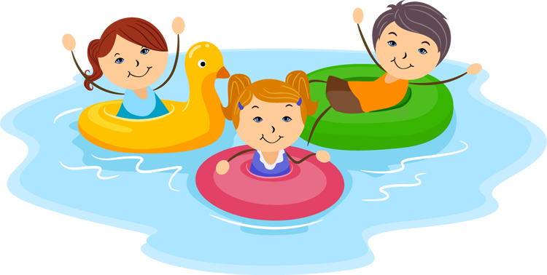
I might while my parents are at work.

At the end of summer, it will be time to go back to school. I will get to see my friends and my teachers again! I will tell them all the fun things I did on my summer vacation. I will listen to the fun things they did on their summer vacation too!

